**ICT Activities**

**Subject: Applied Physics Faculty: Dr. Vivek Singh**

**Class: FE E, F (CSE(DS)), G (IT) and I (EXTC)**

1. **Google Classroom:**

**Link :** [**https://classroom.google.com/u/0/c/NzE5OTk3Nzg5ODE5**](https://classroom.google.com/u/0/c/NzE5OTk3Nzg5ODE5)

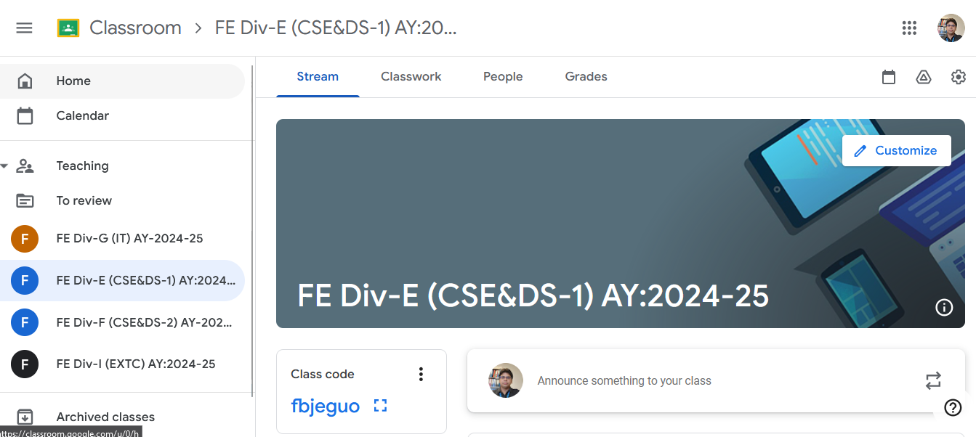

1. **Google Form:**

All F.E students are hereby informed to attempt the AP theory Quiz, Experiment Quiz, Course Exit Survey and Lab Exit survey using the following Google Links on or before 04/12/23

1. Link for theory quiz ( 07/12/2024)

Mod:1 https://forms.gle/EHmTZmo7ijoqmgdC9

Mod:2 https://forms.gle/BUpp4mAZp8gGWJDQ7

Mod:3 https://forms.gle/StZZ8bXUpiEQhVN27

Mod:4 https://forms.gle/3WkW1wuBdG5ZpUzz6

Mod:5 https://forms.gle/7Xm3HvD9WhD846Ah9

Mod:6 Basics of Shttps://forms.gle/XttvujphjSs36awU9

1. Link for Experiment quiz (all modules 07/12/2024)

<https://forms.gle/s7Xf4yh1cPx6TysU9>

1. Link for Course exit survey (09/12/2024)

<https://forms.gle/8muaPjxuwFj6STFZ8>

1. Link for Lab exit survey (09/12/2024)

<https://forms.gle/8muaPjxuwFj6STFZ8>

1. **Suggested online lecture:**

All FE students are hereby informed to go through the following web links for the pre-requisites and important topics of the respective modules this semester.

YouTube links:

Module 3: Interference in thin film

<https://www.youtube.com/watch?v=FDkSeCzDAUY>

Module 4: Electrodynamics

<https://www.youtube.com/watch?v=dt9pLWusnxU>

Module6: Semiconductor Physics

<https://www.youtube.com/watch?v=16SUPbeEy-8>

1. **Online virtual lab experiment**:

Experiment No. 4: Determination of Magnetic Flux Density.: <https://vlab.amrita.edu/index.php?sub=1&brch=192&sim=972&cnt=4>